**Docker Networking:**

* Docker networking is used to establish the communication b/w multiple containers and provide the complete isolation for the containers.

**Types of Docker Network:**

* **Bridge Network:**

It is a default network in docker and it will allow the containers to talk to each other on the same host server.

* **Host Network:**

It will provide the same i.p address for container and host server.It will remove the isolation b/w container and host.

* **None Network:**

It will not provide the i.p address .It will expose port number.

* **Overlay Network:**

It will establish communication b/w multiple containers which are running on the different or multiple host server or docker host.

**Steps to create the docker network and attach the networks to containers:**

* First create the image and container by using docker cli commands.
* Create the networks by using **docker network create network name** command.
* Connect the network to the container by using **docker network connect network name container name** command.

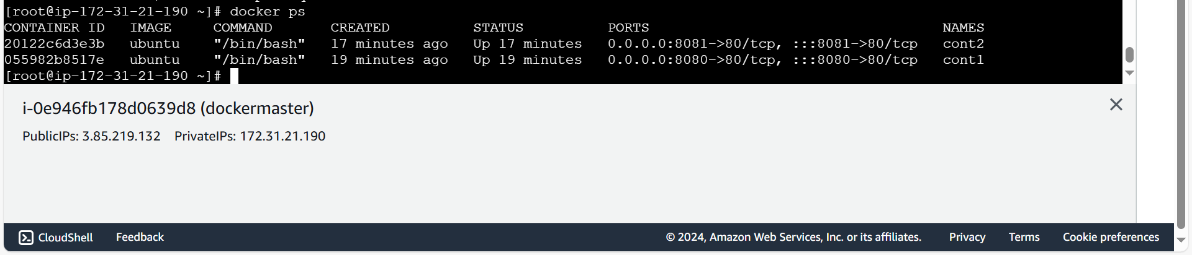

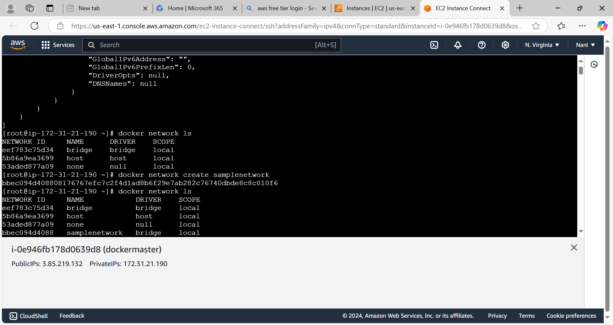

Connect the network to container2

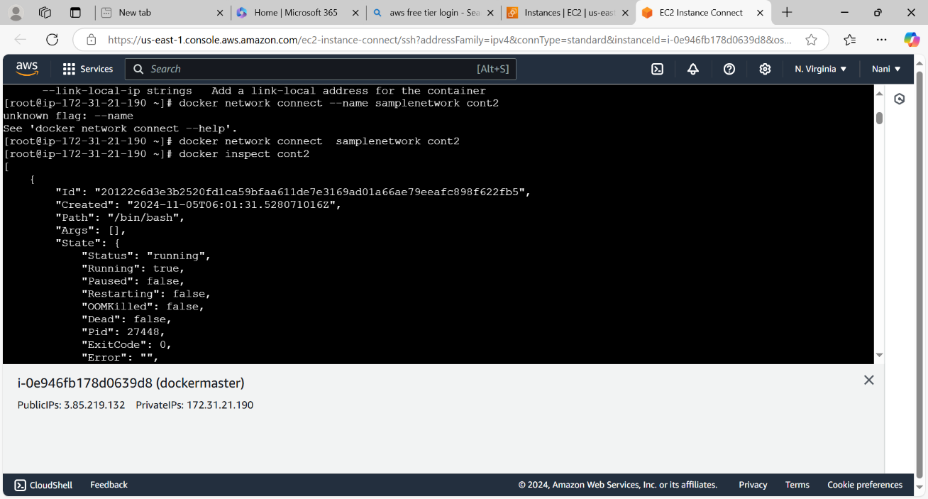

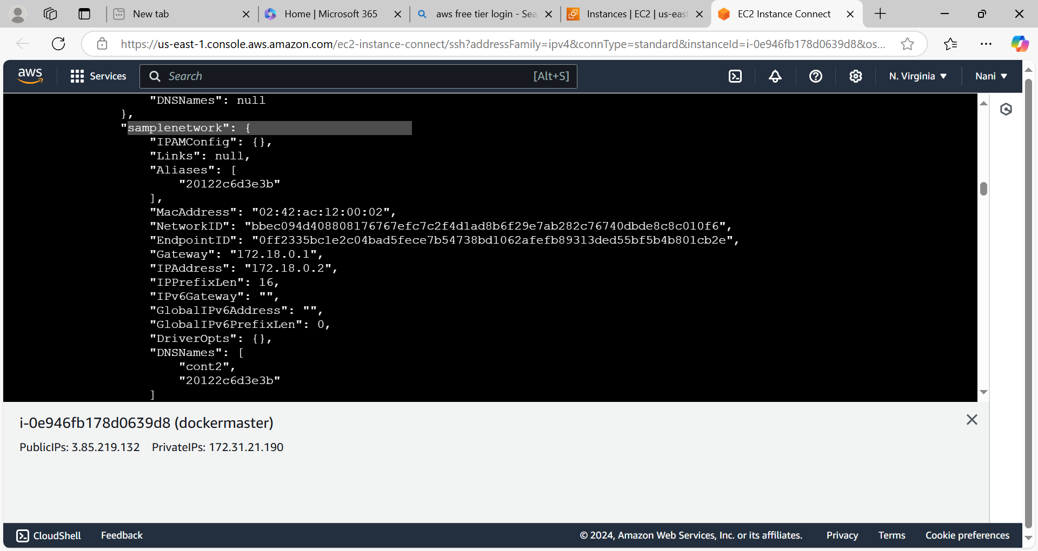

* Attach the same network to another container which container we want to access.

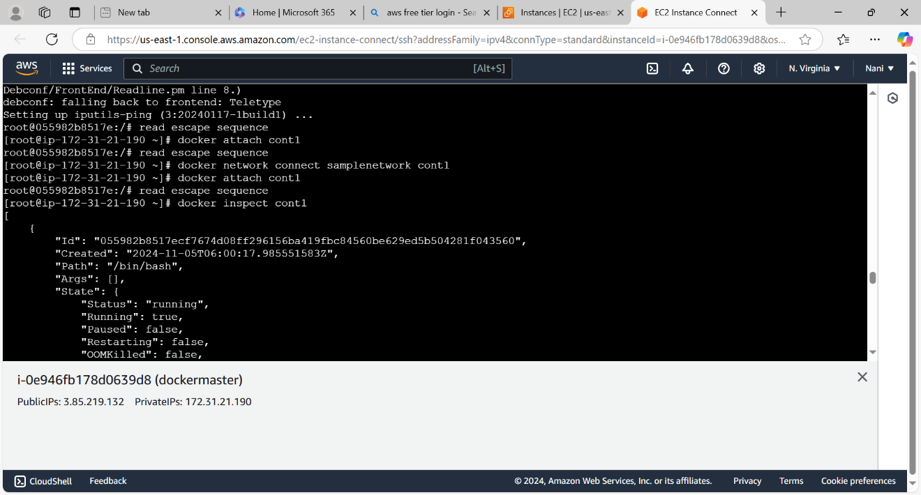

* We can go inside two containers execute **apt update -y** command and install the ping command by using **apt install iputils-ping -y** command.

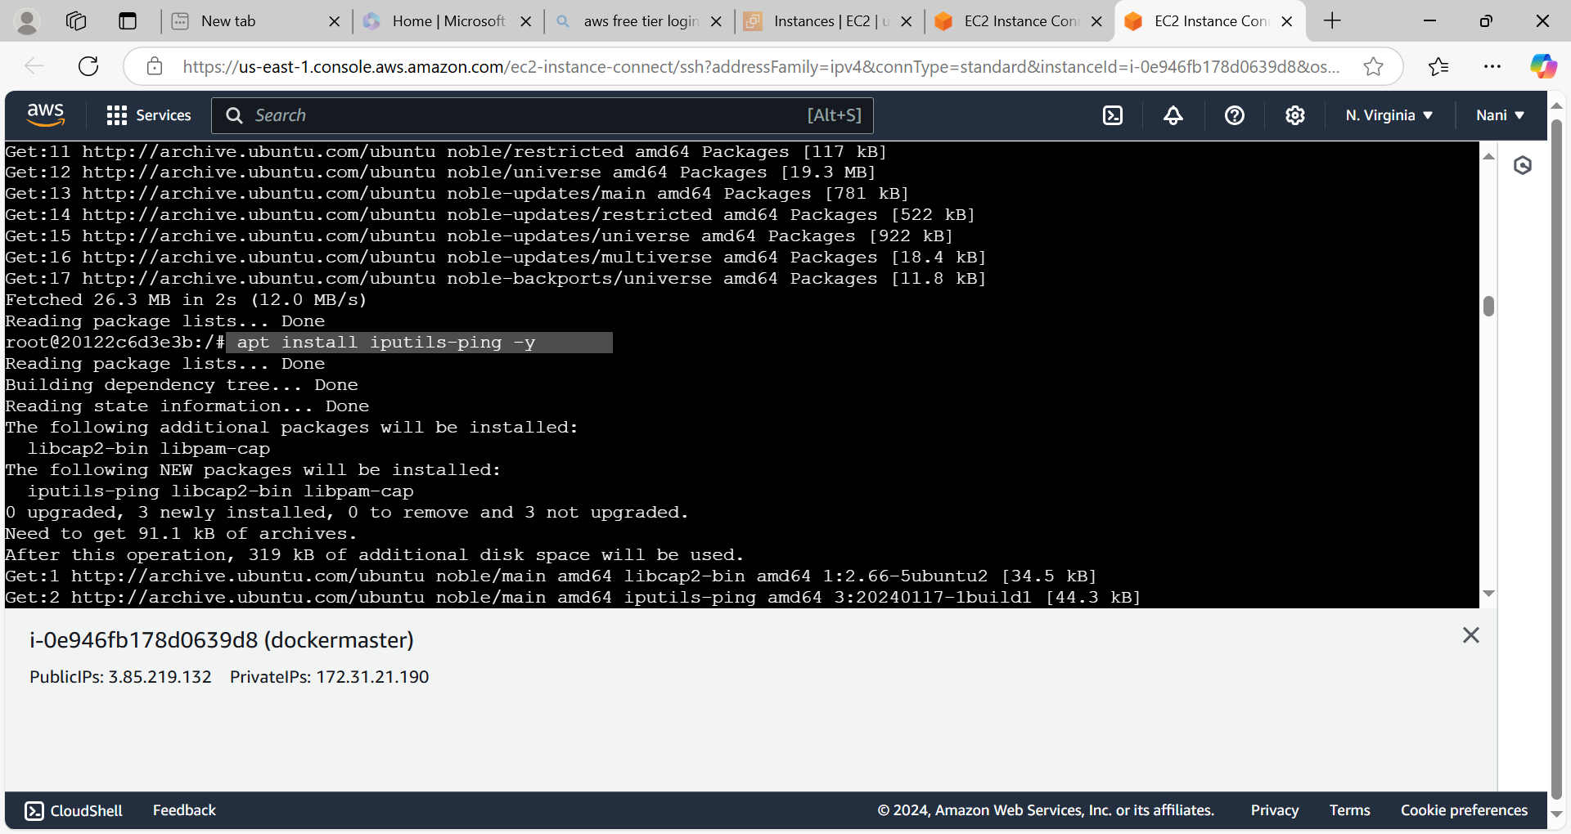

Now we can copy the i.p address of one container(which is available under sample network) and access it from another container by using **ping i.p address** command.

